REACH OUT TO RECONNECT
Our project to visit all homes within the Parish is still ongoing. We are very grateful to our volunteers who have given up their time and made contact with a lot of people. There is still a lot to be done and we need more volunteers. If you are interested in volunteering, please fill in one of the forms which are inside the Church or ask at Reception.
BETHANY BEREAVEMENT SUPPORT GROUP
The Bethany Bereavement Support Group takes place on Wednesday, November 12th & 26th, from 7:30 to 9:00 pm in the Parish Centre. The group provides a welcoming space to share your bereavement journey or to listen to others’ experiences. Our team is there to listen and offer support to all who attend.
ST VINCENT DE PAUL SOCIETY
The monthly collection will take place at this weekend’s Masses, 1st & 2nd November. If you or your family need assistance, our Parish Conference of the Society of St Vincent de Paul is here to help. Contact the East Region helpline: 01-8550022.
BLUE MASS COLLECTION ENVELOPES
Thank you to everyone who has started using the new blue Mass collection envelopes. Just a reminder, you do not need to fill in two envelopes if you want to give to both collections, one envelope is sufficient for both. Please enter the amount that you wish to give to each collection in the boxes provided on the envelope. Also, please do not use the envelopes unless you are giving your name, address or family envelope number. If you do not wish to give your details, please continue to place money directly into the collection bags as usual.

CHRISTMAS RAFFLE
The Christmas Raffle will take place at this year's Christmas Fair on Sunday 30th November 2025. If you would like to donate any new unwanted gifts which we could use as prizes, we would be grateful to receive them at the Parish Centre Reception any weekday morning between 9am and 1pm. Raffle tickets are now on sale €2.00 each or 3 for €5.00.
VOLUNTEERS - BAPTISM TEAM
We are currently looking for volunteers to join our baptism team. If anyone would like more information or to express their interest, please contact the Parish Office Mon-Fri from 9am to 1pm.
CHURCH SHOP
Why not pop by the Church Shop and browse a great selection of new stock for adults and children. The shop is open weekdays and weekends after each Mass.
VOCATIONS
Please keep our seminarians and those discerning a vocation to priesthood in your prayers. If you know of anyone interested in finding out more about becoming a priest, please ask them to contact the Vocations team, Fr Séamus or Fr Bill, at vocations@dublindiocese.ie or bill.oshaughnessy@dublindiocese.ie.
BOOKS
Why not visit our new book section located in
the Parish Centre? Pop by for a browse and if
you see something you like why not take it
away for a small donation.
LOW-GLUTEN HOST
For Holy Communion at each Mass, the priest-celebrant will have a ciborium containing a special section with hosts suitable for communicants with a coeliac condition. There is no need to queue separately - please just indicate to the priest that you wish to receive a reduced-gluten host.

PARISH of LARKHILL
WHITEHALL & SANTRY
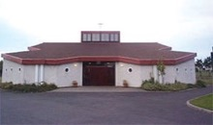
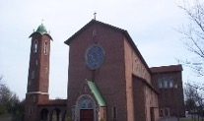


He will wipe every tear from their eyes, and there shall be no more death or mourning, wailing or pain, for the old order has passed away."
(Revelation 21:4)



We remember in prayer our friends and loved ones who have died in the peace of Christ:
Anthony O’Connor
May he rest in peace and rise in glory

THOUGHT FOR THE WEEK
"The souls of the just are in the hand of God, and we, by our prayers, can help
them reach the fullness of light."
(St. Bernard of Clairvaux)

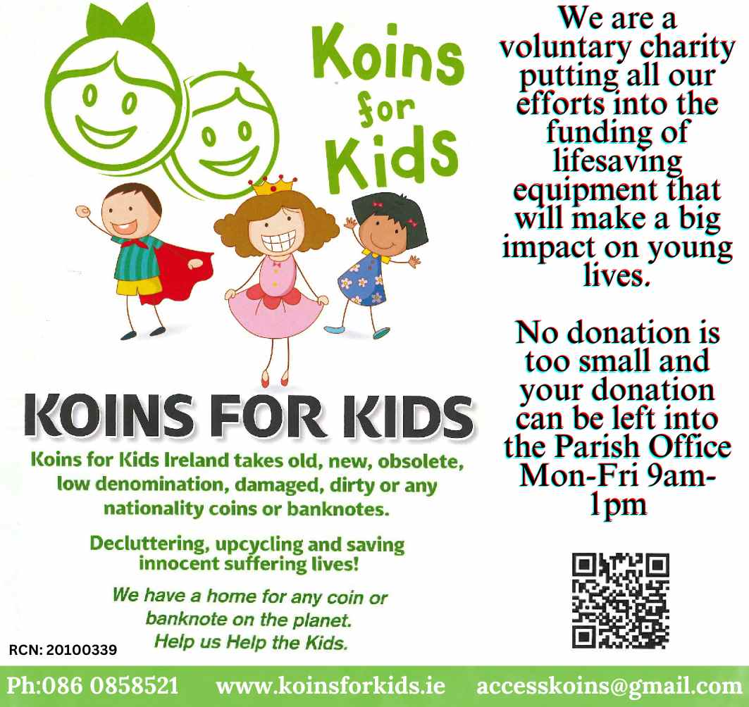

Mass intentions

(from SATURDAY 1st november to sunday 9th november 2025)
Saturday 7pm | Alexander McQueen  Marlene Bonar  Aidan Phillips | 1st Anniversary  3rd Anniversary  5th Anniversary
Sunday 10:30am | Anne Brennan  Sally Timlin | 1st Anniversary  2nd Anniversary
Sunday 12.30pm | Lorraine Crowley  Anne Lindsay  Felix Finlay  Jude Conlan  Cecil Manning  Thomas Colgan  Mary Sullivan | Month’s Mind  Month’s Mind  2nd Anniversary  6th Anniversary  13th Anniversary  Anniversary  RIP
Monday 9.15am | Available for Intention
Tuesday 9.15am | Available for Intention
Wednesday 9.15am | Available for Intention
Thursday 9.15am | Available for Intention
Friday 9.15am | Altar List of the Dead
Saturday 7pm | Ellen Duggan  Sheila McGovern and  her son Alan  Greg O’Toole  Esther Kavanagh  Nora O’Hanlon | 1st Anniversary  5th Anniversary  35th Anniversary  12th Anniversary  RIP  Birthday Remembrance
Sunday 10.30am | Leslie Brooks  Gabriel (Gay) Burke | 3rd Anniversary  4th Anniversary
Sunday 12.30pm | Sean Hayes  Carmel Craddock  Eammon Hughes  Rita Phelan  Joe Briscoe  John Wolfe also remembering Sarah, Ann & Elaine Wolfe | 1st Anniversary  5th Anniversary  5th Anniversary  Anniversary  Anniversary  Anniversary
CHAPEL OF BLESSED MARGARET BALL
Sun 2nd Nov 10am | Patricia Fortune  Jim Hayden  William & Bridget Knowles  also remembering their daughter Carole | 1st Anniversary  Anniversary  Anniversaries
Wed 5th Nov 10am | Available for Intention
Sun 9th Nov 10am | Charles E. Maguire  Jack & Jean O’Reilly | 16th Anniversary  Anniversaries
If you would like your Mass intentions to be included in the parish newsletter, please submit them
to the Parish Office on or before the Tuesday preceding the requested date of the Mass.

If you would like to submit something for inclusion in the newsletter, please contact the Parish Office.

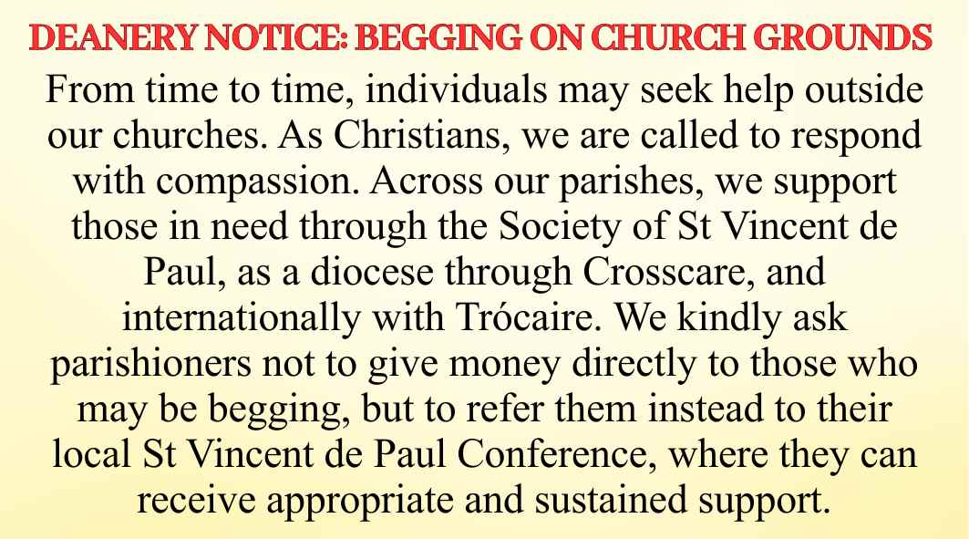
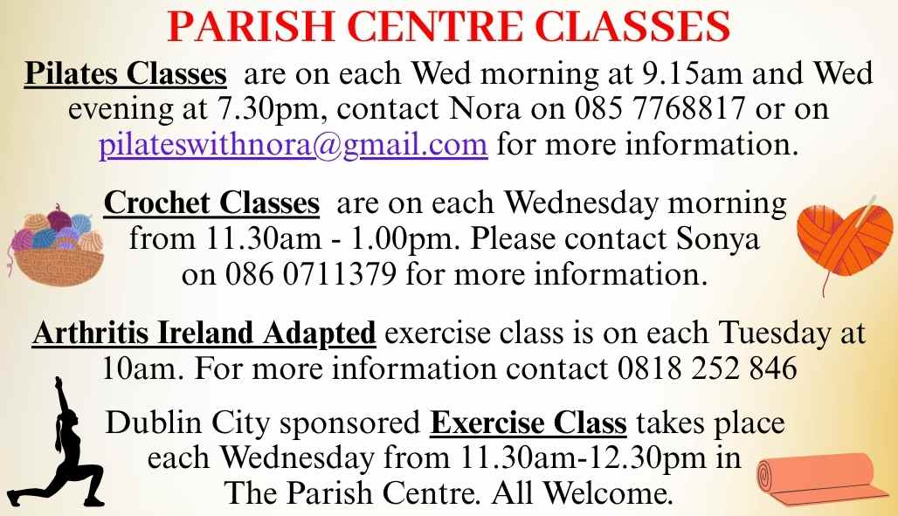

Contact Information
Parish Priests: | Fr Robert Smyth / Fr Dominic Kwikiriza
 | Fr Tom Kearney / Fr John Jones / Fr Martin Harte
Email: | whitehall@dublindiocese.ie
Parish Office Tel: | 01 8375274 Mon – Fri 9am to 1pm
Parish Website: | www.whitehall.dublindiocese.ie

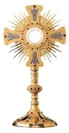
RCN: 20016166

CHURCH OF THE HOLY CHILD

Masses
Monday to Friday: 9:15am
Saturday: 7:00pm
Bank Holidays: 10:00am
Sunday at 10:30am & 12:30 pm
All Masses will be broadcast live on the Webcam

Confessions
The Sacrament of Reconciliation is celebrated after the 7pm Saturday Mass or on request.

Church Opening Times
Mon to Fri: 08:45am - 12:00pm
Saturday: 6:30pm until after Mass
Sunday: 10:00am until after 12:30pm Mass
BAPTISM
The Sacrament of Baptism is normally celebrated on Saturdays at 12pm. This can be arranged by appointment with the Parish Office at least one month in advance of the Baptism.
ADORATION
Monday to Friday from 9.45am
to 11.45am in the Oratory.
CHAPEL OF BLESSED MARGARET BALL

Masses
Sunday: 10:00am
Wednesday: 10:00am
BAPTISM
The Sacrament of Baptism is normally celebrated on Saturdays at 12pm. This can be arranged by appointment with the Parish Office at least one month in advance of the Baptism.

Collections for 26th oct
First Collection: | €1,780
Mission Sunday: | €1,020
Family Envelope: | €836.15
Up-Keep Fund: | €355
Thanks to all who support our collections.

PARISH UPKEEP FUND
Envelopes for the Parish Upkeep Fund will continue to be available in the Church and Parish Centre.

Parish Newsletter 2nd November 2025
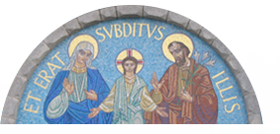
Church of the Holy Child
The Thatch Road, Whitehall, Dublin 9

Chapel of Blessed Margaret Ball
Oak Park Avenue,
Santry, Dublin 9

